Hunger and Fullness Scale
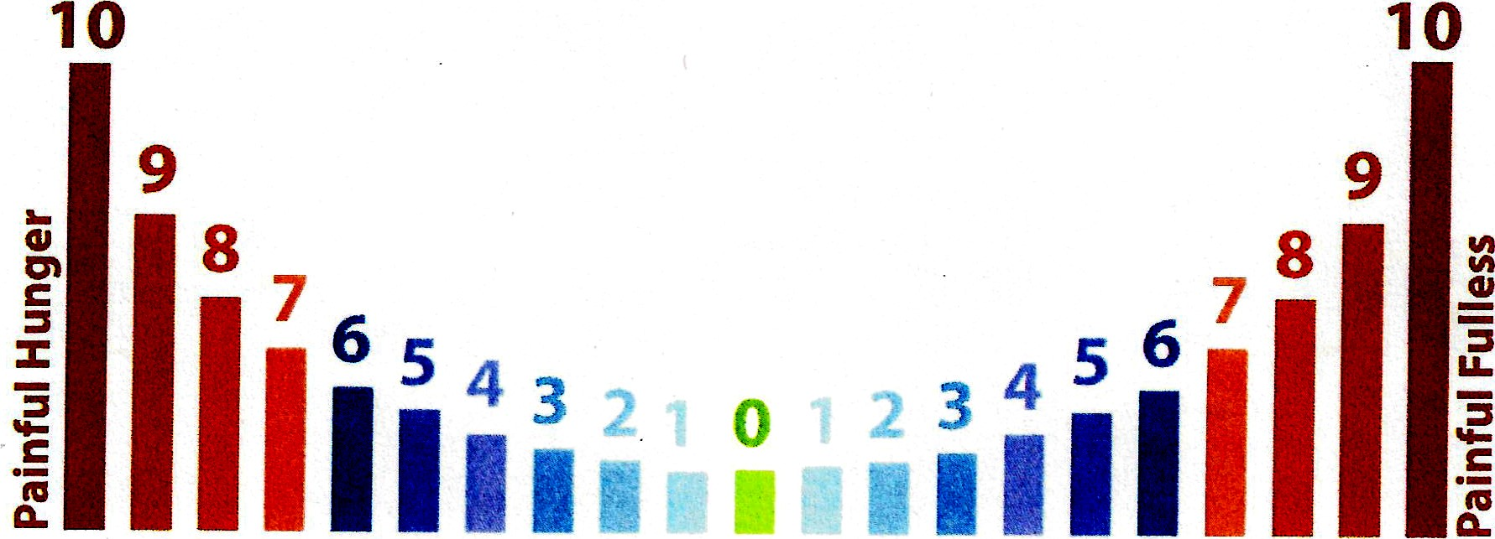
Uncomfortable Comfortable Slight Comfortable Uncomfortable

